EXP NO:2
Aim:
Apply Gaussian blur for image smoothing using OpenCV.
Algorithm:
Import OpenCV and Matplotlib required Python libraries.
- Read input image from specified file location.
- Apply Gaussian blur using five-by-five kernel size.
- Convert original image from BGR to RGB.
- Display blurred image using Matplotlib visualization function.
- Compare original and blurred images for smoothing.
Program:
import cv2
import matplotlib.pyplot as plt
img = cv2.imread("/content/Picture2.jpg")
blur = cv2.GaussianBlur(img, (5,5), 0)
plt.imshow(cv2.cvtColor(img, cv2.COLOR_BGR2RGB))
plt.show()
plt.imshow(cv2.cvtColor(blur, cv2.COLOR_BGR2RGB))
plt.show()
Output:
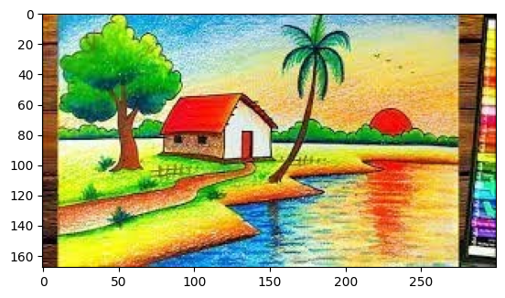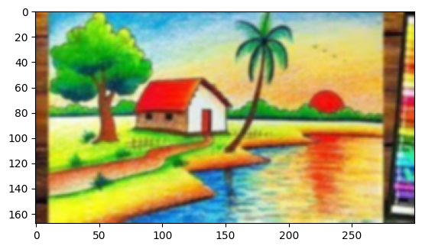
Result: The input image was successfully smoothed using Gaussian Blur, and both the original and blurred images were displayed successfully.

